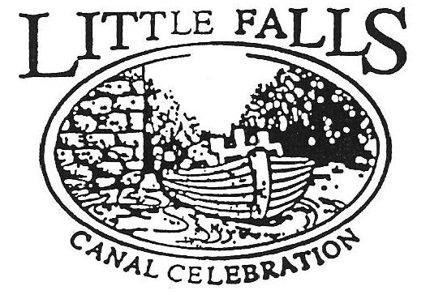

Program Registration
30th Annual Little Falls Canal Celebration
August 06 – 12, 2018

This Form must be completed and returned by ASAP to be included in the Program brochure schedule.
This is a Free listing. Paid Ad Listing will be mailed separately.

Program Information:
Name of Program (as it will appear in promotional releases): Brought back by popular demand!

Growing Up on The Southside 1957 – 1970 - A Walking Tour In To the Past V!
Program Location:_The Southside Start and end at Ann St Market. Walk 3-4 miles. Stops include Benton Landing, Lock 17, Danube St, Jefferson St, Railroad St, Casler St, Flint Ave, Southern Ave, etc.

Program Date(s):__Saturday August 11, 2018________________
Program Time(s):____10:30AM – 12:30PM? Tentative TBD based upon pace of attendees
Program Entry Fees:_____No cost__Donations to LF Historical Society Welcomed

Program Description (brief): The “Tour” will focus on growing up on the Southside from 1957 to 1970 with a theme that this was not “Leave It To Beaver”; “Ozzie and Harriet”, “My Three Sons”; “Donna Reed”, etc. but a very different and special experience. “Southsiders” welcomed to join and share in the story telling!

Is there a program application? Yes______ Please attach Not needed____X_______
Advance sign up by email would be appreciated.

Contact Person: ___Gary T. Staffo ______________________________________________

Address:__13764 Fleet Street, __Woodbridge, VA 22191-5400________

Telephone:Home___703-866-2023___Office_202-586-9577___Cell__202-415-6662__

E-mail Address__Gary.Staffo@hq.doe.gov__

Special Needs: NOTE: Walk includes unpaved dirt paths, uneven surfaces, climbing up and down stairs, etc. Moderate to vigorous physical activity. Water, sunglasses, hat, sun tan lotion, comfortable shoes.

Please complete and return to: ASAP

Little Falls Canal Celebration
C/o Tony DeLuca
Little Falls Family YMCA
15 Jackson Street
Little Falls, NY 13365
Telephone: (315) 823-1740

